Give the gift of superior sound this Valentine's Day

**For the love of sound - Sennheiser’s Valentine’s Day Gift Guide**

***Sydney, Australia, 4 February 2022* – As the most romantic day of the year approaches, loved ones can show each other how much they care by giving the gift of sweet sound. For partners who want a more unique gift than roses and chocolates, their Valentine is sure to be swept off their feet with incredible headphones and the perfect symphony of love songs.**

With styles to match every lover, Sennheiser has headphones to remind lucky recipients of their partner's love year-round. More than just a celebration for lovestruck couples - Valentine's Day is the perfect excuse to practice self-care and indulge your ears by listening to your favourite tracks.

**For the love of me time -** [**CX Plus True Wireless**](https://en-de.sennheiser.com/cx-plus-true-wireless)

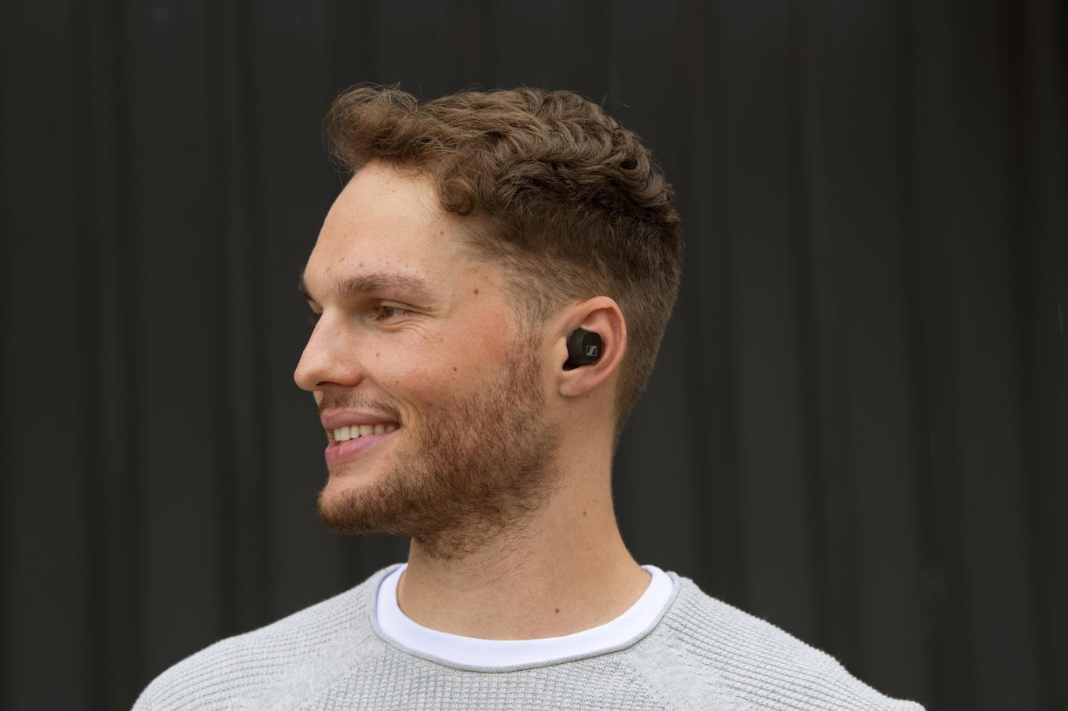

* Active Noise Cancellation for undisturbed listening pleasure
* The bespoke TrueResponse transducer delivers crystal-clear sound
* Personalised sound thanks to Bass Boost and the Built-In Equaliser
* 9-hour battery life (+18 hours with the case)
* Available in black or white from Sennheiser and leading retailers

**For the love of bass -** [**CX True Wireless**](https://en-au.sennheiser.com/cx-true-wireless)

* The bespoke TrueResponse transducer delivers crystal-clear sound
* Personalised sound thanks to Bass Boost and the Built-In Equaliser
* Passive Noise Cancellation for undisturbed listening pleasure
* 9-hour battery life (+18 hours with the case)
* Available in black or white from Sennheiser and leading retailers

**Never miss a (heart)beat with the** [**HD 350BT**](https://en-au.sennheiser.com/hd-350-bt)

* Great sound with deep dynamic bass
* Flawless transmission assured by the latest wireless technology, including Bluetooth 5.0 and high-quality wireless codecs
* An impressive 30-hour battery life and fast USB-C charging
* A compact folding design that fuses comfort and minimalist style
* Available in black or white from Sennheiser and leading retailers

**Take their love of audio further with** [**HD 458BT**](https://en-au.sennheiser.com/hd-458bt)

* Active noise cancellation for uninterrupted listening pleasure
* Great sound with deep dynamic bass
* Flawless transmission assured by the latest wireless technology, including Bluetooth 5.0 and high-quality wireless codecs
* An impressive 30-hour battery life, fast USB-C charging and compact folding design
* A red colour accent gives a fresh but minimalist design
* Available from Sennheiser and leading retailers

**Earbuds that delight on a budget -** [**CX 300S**](https://en-au.sennheiser.com/earbuds-in-ear-headphones-cx-300-s)

* Built-in microphone and remote for call and music control
* Ergonomic in-ear design for ambient noise isolation and undisturbed listening
* Tough and tangle-free cable for long-lasting listening enjoyment
* Available in black, white or red from Sennheiser and leading retailers

**Local Press Contacts**

Gabby Wallace

+61 431 045 932

gabby.wallace@groundagency.com

Dan Tompson

+61 421 907 317

daniel.tompson@groundagency.com